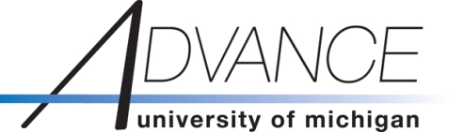

WINTER 2017 LIFT Core Competency Seminar

Promoting Yourself via Building Academic Community:
A Practical and Hands-on Why-to and How-to

Thursday, February 2, 1:30-3:00pm
Michigan Union (Pond Room)

Presenter:
Sari van Anders, Ph.D.,
Associate Professor of Psychology and Women’s Studies
University of Michigan

Self-promotion can feel awkward, slimy, or inauthentic; it doesn’t have to. As counterintuitive as it may seem, self-promotion can be an important part of building your academic community and can be critical to certain kinds of recognition and opportunity. In this interactive workshop, we will discuss why we should self-promote and how to do it, using concrete examples of what has worked in the presenter’s experience and how. We will use hands-on activities and exercises (bring your laptop!), and folks will take home individualized examples to jump-start or enhance your own practice. In addition, we will discuss how our own social locations may affect the ways we do and/or don’t self-promote. The workshop’s discussions will be situated within notions of building connectedness and situating you (more) in your discipline and related networks.

The LIFT (Leadership and Integration in Faculty Transitions) Core Competency Seminar Series fosters skills to facilitate the success, empowerment, and satisfaction of individual faculty, while enabling and informing their contributions to their departments, disciplines, and other forms of academic community.
The LIFT Core Competency Seminars are open to all University of Michigan tenured or tenure track faculty on a first-come-first-served basis (Registration is required).

Please contact advanceprogram@umich.edu for additional information.

1214 S. University Avenue, 2nd Floor, Suite C - Galleria Building, Ann Arbor, MI 48104-2592
Email: advanceprogram@umich.edu*Phone: 734.763.8706*Fax: 734. 647.6112

