FACULTY PERFORMANCE EVALUATION: FY2021
Introduction: The mission of the University of Michigan Medical School is to transform health through bold and innovative education, discovery and service. All faculty members have a responsibility to enable and contribute to this mission by demonstrating high standards of professional expertise. Faculty are directly accountable to their departmental leadership and each other.
About this template: This template was created to assist Medical School departments by providing a faculty evaluation that is structured and streamlines workflow. Departments may use and/or amend the format of this template to serve their needs best while advancing the state of their annual faculty evaluations. Departments currently utilizing or approaching fully structured qualitative and quantitative evaluations may simply use this template for reference as they refine their existing annual faculty evaluation process. Items are color-coded based on who typically completes the task department staff, faculty member, or evaluator.
Instructions:
- Department Staff – for each faculty evaluation: edit the footer accordingly; pre-populate the Performance Snapshot.
- Faculty – Review Performance Snapshot and complete Self-Assessment; send to faculty evaluator.
- Faculty Evaluator – Review Self-Assessment and Performance Snapshot for evaluation period.
- Faculty Evaluator – Complete the Performance Assessment.
- Faculty Evaluator with Faculty – Meet to review the performance assessment and document the Annual Expectations for the upcoming year; sign and date the completed evaluation.
- Department Staff – provide a copy to the Faculty and securely file this and related documentation.

Michigan Medicine Mission: “We advance health to serve Michigan and the world.”

Our Vision: “Our discoveries change care. Our care changes lives.”

Our Values: “Caring, Innovation, Inclusion, Integrity, Teamwork”

Faculty Expectations
Instructions: Evaluators meet with faculty to review expectations before writing the evaluations.

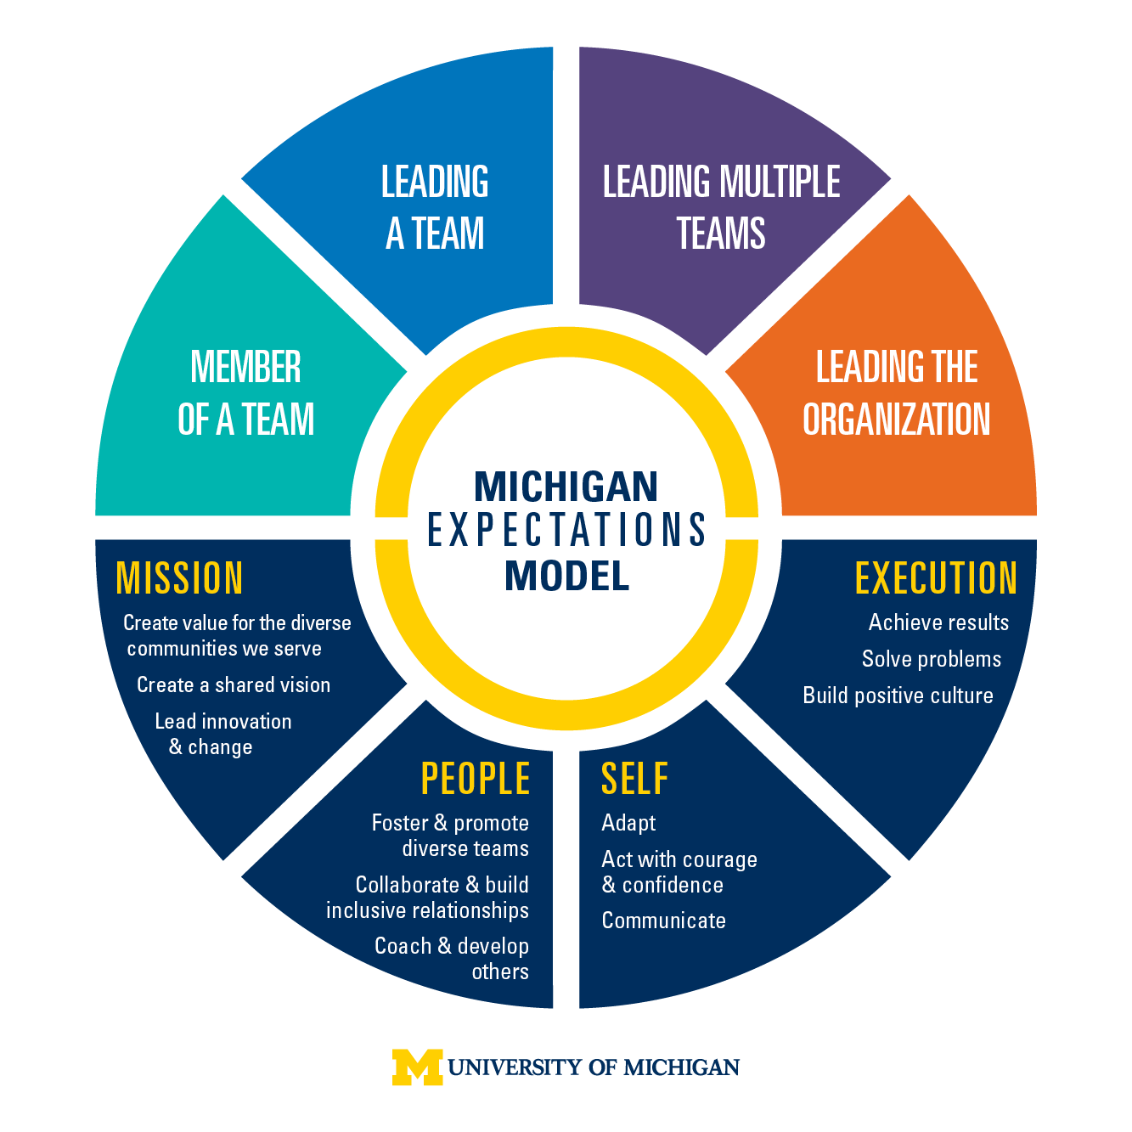
Michigan Expectations Model:

The Michigan Expectations Model focuses on key areas for being a part of and leading a team.

These are the four core areas that pertain to your annual evaluation.

Mission -

People -

Self -

Execution -

Faculty Performance Snapshot for Evaluation Period
Instructions for department staff: Pre-populate activity and metrics to the extent possible and give to faculty member one month before their scheduled evaluation. Pre-populate on page 3 for the following areas:

PEOPLE – Provide relevant metrics related to professionalism (e.g. adherence to policies, participation in departmental functions, etc.)

DISCOVERY – Provide relevant metrics on effort protection and grant support.

EDUCATION – Gather metrics from teaching evaluations from students, Education Value Units (EVUs) and teaching awards or leadership.

CARE – Provide information on wRVUs, new patient/total visits, OR cases, patient access and satisfaction, documentation metrics, quality indicators, etc.

SERVICE – Provide metrics on formal leadership role performance

Instructions for the faculty member: Review your expected effort allocation, activity and output and other metrics provided by department staff. Complete the following section as updates for accomplishments for the year.

PEOPLE
Please provide any updates as they apply to professionalism, civility (e.g. teamwork, collaboration, etc.) and diversity promotion.

DISCOVERY
Please complete this section with metrics which apply to Grants, Papers, Presentations, Awards.

EDUCATION
Please complete this section with major teaching accomplishments or awards

CARE
Please discuss any accomplishments in the area of clinical care, quality metrics, quality improvement or patient care.

SERVICE
Please confirm any leadership roles and describe any formal or informal committee service (Medical School, Departmental, Clinical Enterprise, local, and/or national) or outreach activities.

Faculty Self-Assessment for Evaluation Period
Instructions: Complete the following questions, describing your key accomplishments from the previous year that are not currently included in the performance snapshot and/or other provided materials and build your goals for the upcoming year. Ideally your goals should be SMART – specific, measurable, actionable, results-focused and time-bound.

- Summary – Describe your most meaningful contributions for this evaluation period.

- Reflection – Describe your progress against the goals you set for the prior year.

- Goal Setting – What do you plan to achieve during the upcoming year (using the SMART goal framework)?

- Professional Development – What personal professional development activities have you undertaken in the last year? What personal professional development activities do you plan to pursue in the next year?

- Mentorship Network: Please provide an outline of your mentorship network:

- Your mentors – Who they are, areas of mentorship they provide, and how they have supported you over the previous year.

- Your peer mentors – Individuals and groups

- Your mentees – Names and areas in which you mentor them

- Wellness – If you are willing to share, reflect on your perceptions of your own wellness and/or burnout. Are there strategies you wish to deploy in the coming year to optimize your wellness?

- Diversity Equity and Inclusion (DE&I): Contributions and Impact – Describe your actions and their impact for promoting the benefits of diversity, equity, and inclusion on the outcomes of our mission.

Faculty Performance Assessment for Evaluation Period
Instructions: Faculty evaluator to complete this assessment. Reference any specific goals set for the faculty member to support the evaluation.

- Rate your colleague’s contributions in each area. Provide details about areas where the faculty member exceeded expectations or where improvement is needed. Enter an N/A if the faculty member is not involved in the specific mission area.
Performance Rating Scale
Outstanding - The individual’s achievements are superior in a particular area or comprehensively. Demonstrated or achieved a distinction or accomplishment viewed as outstanding.
Excellent - Consistently does more than is required in a particular area or comprehensively.
Satisfactory - Performance is fully satisfactory in all major respects.
Needs Improvement - Performance is inconsistent or problematic in one or more areas. A plan for improvement should be developed by the faculty member in consultation with the Chair or Chief.
Unsatisfactory - Faculty member consistently fails to meet acceptable standards in one or more areas of evaluation. A plan for improvement should be developed by the faculty member in consultation with the Chair or Chief.

Faculty Expectation | Rating | Comments and examples
PEOPLE (Professionalism)
DISCOVERY
EDUCATION
CARE
SERVICE

- Review specific faculty goals for the evaluation period; comment on progress toward those goals; discuss goals for the next year.

- If the faculty member holds an administrative position, collect feedback on performance and then summarize performance against expectations for this role.

- Provide any additional comments on performance from the prior year.

- Discuss career development and promotional considerations for the next year and beyond.

Statement on Faculty Compensation Related to This Evaluation
Your merit increase and overall compensation is based on academic track and rank, years of service and/or years in track and rank, performance relative to expectations set forth in this evaluation for one, two or all three missions and for your citizenship and leadership contributions. Your annual performance relative to expectations and rank promotions are the primary factors which determine your merit increase. Our departmental faculty compensation plan sets forth the detail of all compensation including incentive.

Faculty Expectations for Upcoming Year
Document the faculty goals for the upcoming year. Goals to be jointly developed and agreed upon by the individual faculty member and the Department / Division. The goals should focus on clinical, educational, scholarship, citizenship, service and/or administrative areas as well as any other personal goals.

Signatures: Faculty evaluator and faculty member should each sign and date in the space below.

Signature of Faculty Chair / Chief: ___________________________________

Signature of Faculty*: ______________________________________________

- The faculty member’s signature indicates that this performance evaluation took place and a copy was given to the faculty member. The signature does not signify the faculty member’s agreement with this evaluation.

